EVENT FORM

Project title | Development of master curricula for natural disasters risk management in Western Balkan countries
Project acronym | NatRisk
Project reference number | 573806-EPP-1-2016-1-RS-EPPKA2-CBHE-JP
Coordinator | University of Nis
Project start date | October 15, 2016
Project duration | 36 months

Project number: 573806-EPP-1-2016-1-RS-EPPKA2-CBHE-JP

"This project has been funded with support from the European Commission. This publication reflects the views only of the author, and the Commission cannot be held responsible for any use which may be made of the information contained therein"

EVENT DESCRIPTION

Date | 24 April 2019
Author | Radoslav Ivanis
Institution | University of Banja Luka
Event title | Monitoring of the Project

Event description:
The monitoring visit for the above mentioned project was implemented by Suad Muhibic, Head of the National Erasmus+ Office in BiH and Dejan Rosic, Project Officer, on April, 24th 2019 (09:00-14:00) at the Faculty of Security Studies of the University of Banja Luka.

The purpose of the visit was to learn about the activities realized and products developed so far, as well as to observe if the project has encountered any problems in operational and/or financial implementation that can be discussed and solved.

Darko Paspalj, vice dean, informed representatives of Erasmus+ Office in BiH of project activities realized so far and stressed the importance of the project for Faculty. Professor Paspalj also gave information on making class schedule and professor election process.

Radoslav Ivanis had a presentation on activities realized so far and activities planned to be realized until the end of the Project. Radoslav Ivanis, also a student on this master program gave his experience as a student considering organization of lectures, exam held etc.

Professor Velibor Lalic gave his experience as a teacher at this master program.

Attachment

Photos (jpg) | Photos
Other personal remarks

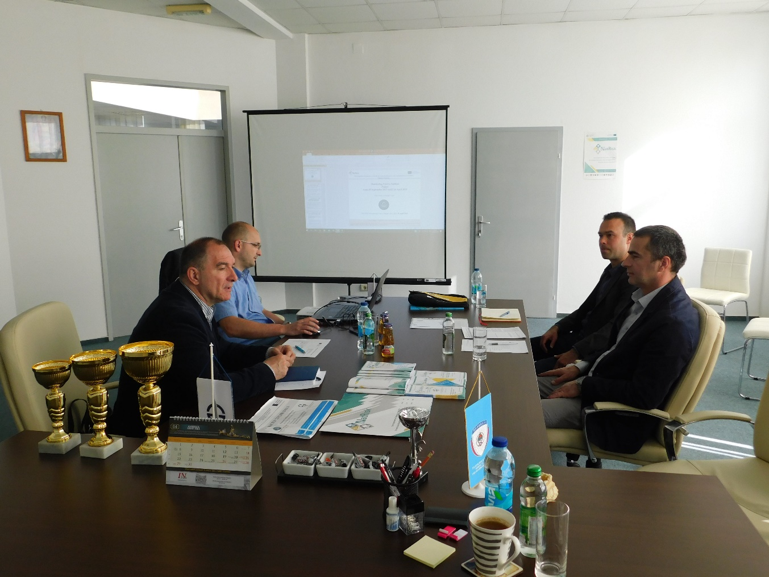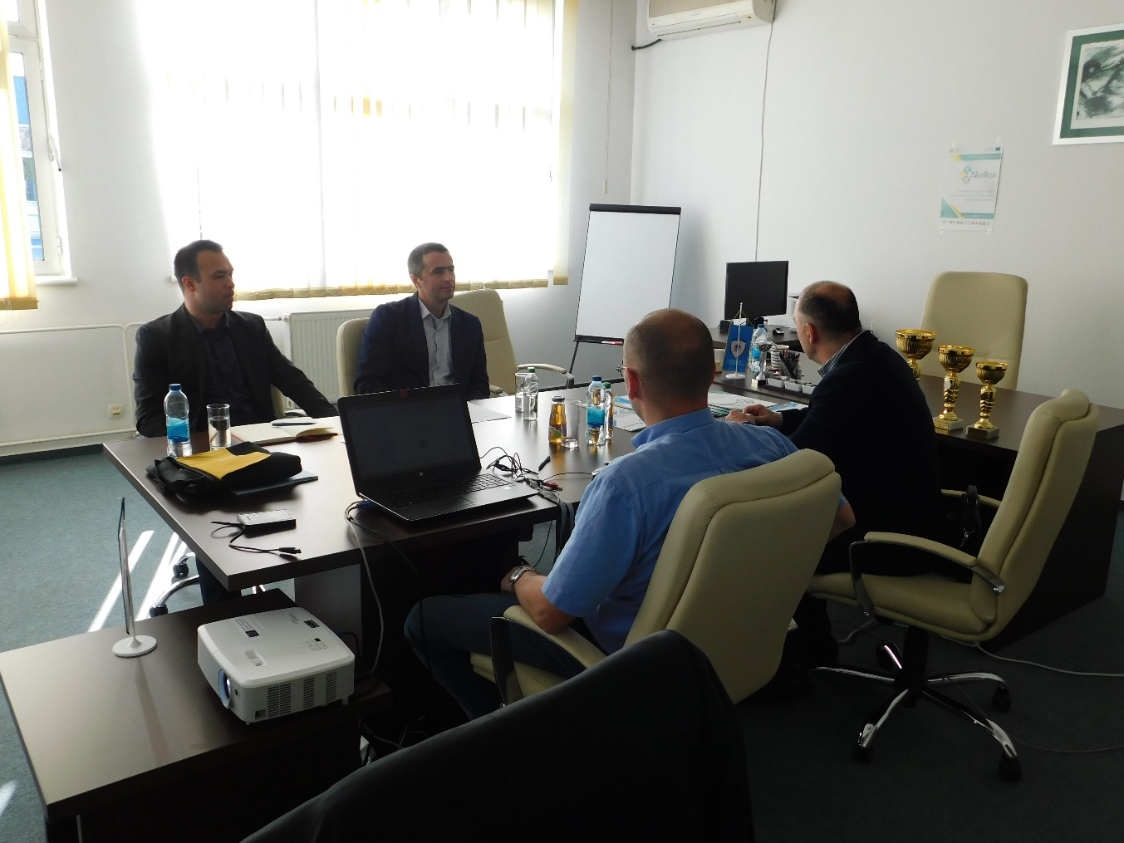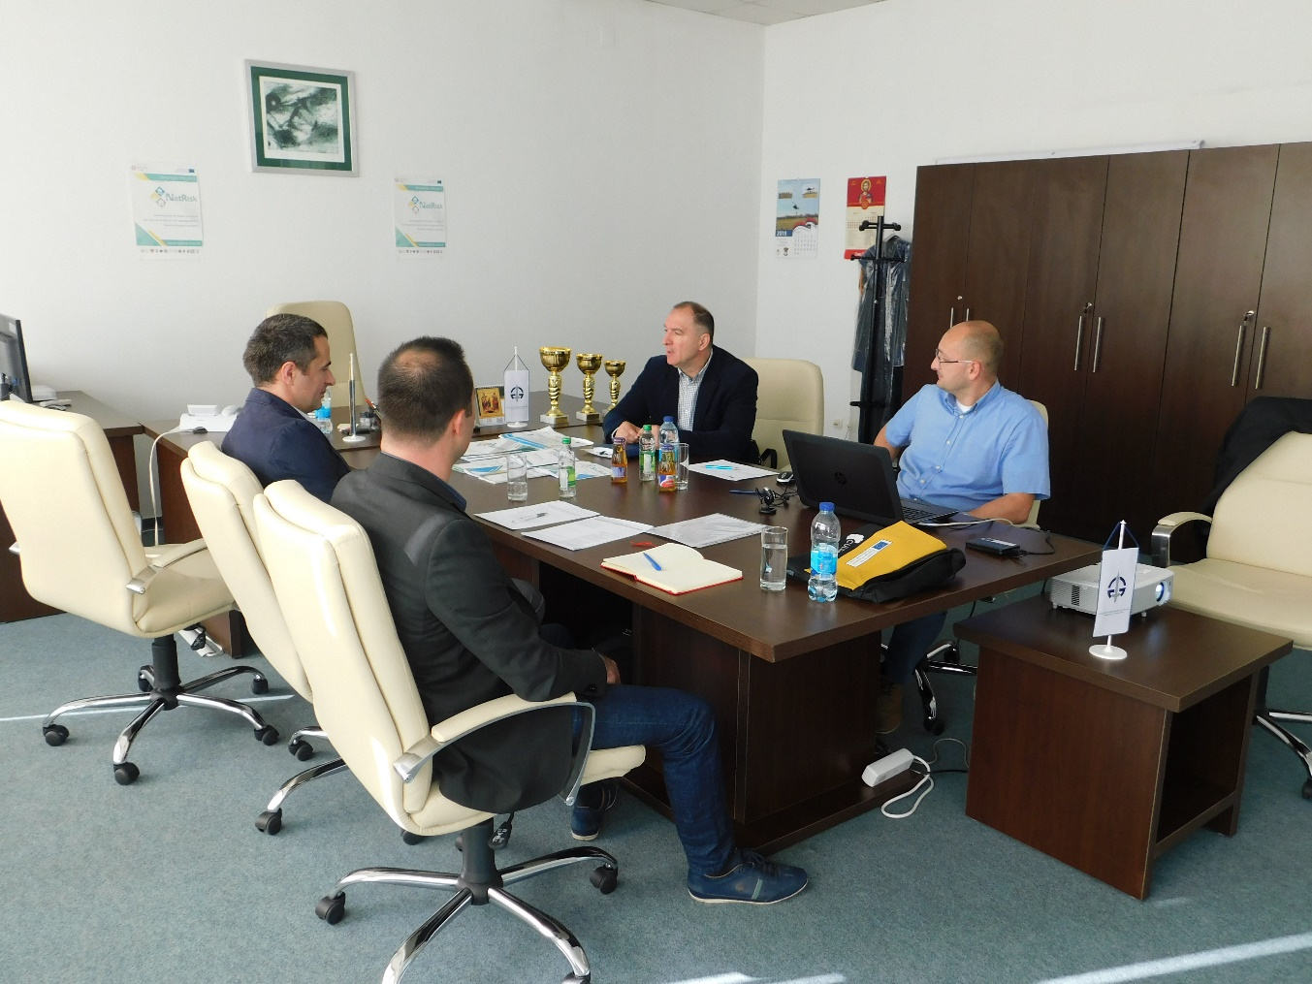

Location, date Signature
Banja Luka, 24 April 2019 Radoslav Ivaniš

This template has to be filled by NatRisk project partners for informaing about promotional events to the coordinator, on e-mail address: natriskuni@gmail.com.

